Skill: Literacy (optional trial)

4 - Advanced | 3 - Proficient | 2 - Partially Proficient | 1 - Developing
In addition to proficiency, I can connect and synthesize ideas within an unfamiliar context. | I can accurately obtain, and communicate historical information using all success criteria.  - Accurately applies ELO content | I can obtain and communicate historical information using some of the success criteria. | I attempt to obtain and communicate historical information.
ELO Specific Content: I can summarize the key elements of Christianity.

Success Criteria  (*all are needed to achieve proficiency) | Feedback
Obtain  - / -- | - I am able to talk to the text  - Underline words I don’t understand  - Create questions about the information in the reading as you are reading (one per paragraph)  - Multiple sentence summaries for each paragraph or section
Communicate  - / -- | - I am able to create a clear, concise and accurate summary of the reading  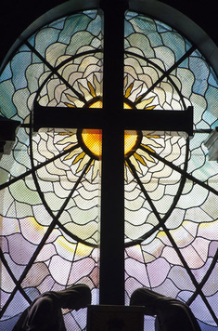  - Could be one summary or multiple small summaries.  - Could be notes  - Oral response


Christianity: Origins and Development The second world religion to emerge in the Middle East was Christianity. The birthplace of Christianity was a territory at the eastern end of the Mediterranean Sea. The Romans called it Judea. It had once been a part of the ancient Kingdom of Israel. The first Christians were Jews and maintained many Jewish beliefs. They worshiped one God, valued taking care of the needy, recognized Abraham as a prophet, and believed the Hebrew Bible was holy. But Christianity soon developed its own doctrine and a much larger following.
The origins of Christianity lay in the life and teachings of Jesus, considered by Christians to be the Son of God. The story of Jesus is based largely on accounts in the New Testament of the Christian Bible. Born in the Roman province of Judea about 6 B.C.E., Jesus was a Jewish teacher. When he was around 30 years old, he left home to travel across Judea and teach the word of God.
Jesus taught that God was merciful and loving and that people should love God and their neighbors. He said that those who lived according to God's will would be forgiven their sins and relieved of suffering. The Christian Bible says that Jesus healed the sick and performed other miracles. In the process, he gained many followers. Among them were twelve special disciples known as the apostles, who were given the task of spreading Jesus' message.
Soon, some people began calling Jesus the Messiah, or “anointed one,” chosen by God to save humankind. He later became known as Christ, the Greek term for Messiah. The Roman authorities who ruled Judea saw Jesus as a troublemaker, however. They feared that he might spark a rebellion among the Jews. They arrested him and sentenced him to death.
The New Testament of the Christian Bible tells that around 30 C.E. Jesus was put to death by crucifixion, a common form of execution used by the Romans. According to the New Testament, friends placed his body in tomb. The New Testament says that three days later Jesus rose from the dead and then appeared to his disciples. Christians call this event the Resurrection.
For Christians, the Resurrection proved that Jesus was a holy savior. They said that anyone who recognized him as the Messiah would enter the Kingdom of God. Although the Romans often persecuted Christians, Christianity gradually spread throughout the empire. Paul, who was named an apostle after Jesus' death, played a key role by bringing non-Jews into the faith.
Eventually Christianity became the official religion of the Roman Empire. Over time, the Roman Catholic Church became rich and powerful. The Christian faith later divided into Catholic, Orthodox, and Protestant branches. But Christianity as a whole continued to expand.

Summary:

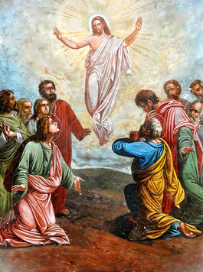
The Beliefs of Christianity The Christian holy book is the Bible. It consists of two parts. The Old Testament is the Hebrew Bible, which Christians recognize as the word of God. The New Testament is a collection of stories and teachings written by various people who knew Jesus or played key roles in the early Christian church. The New Testament contains the Gospels, which are accounts of Jesus' life and teachings.
Christian doctrine is complex, with many different interpretations. But several key ideas are found among almost all Christians. One of these is the Trinity. According to Christian teaching, God consists of three beings in one—Father, Son, and Holy Spirit—in a union known as the Trinity. Christians believe that God the father is the creator of the universe. They believe that God the son is Jesus, known to his followers as Jesus Christ. And they believe that the Holy Spirit is God's presence and power at work in the world today.
Christianity also teaches about the Resurrection and salvation. They believe that Jesus rose from the dead and lives in heaven. They also believe that God can save people from sin and grant then everlasting life after death. This belief is called salvation. Many Christians believe that salvation depends on God's grace, which is God's gift of love and divine assistance which absolves people of their sins. This gift is said to be open to all who believe in Jesus and ask for God's forgiveness.
Christians practice their faith by trying to follow Christ's moral teachings and by observing certain customs and rituals. Many go to church on Sunday to worship and pray. They may also perform sacred rituals called sacraments. One sacrament is baptism, which makes a person a member of the Christian church. Another is Holy Communion, the symbolic sharing of bread and wine. This ritual mirrors the Last Supper, the final meal the New Testament says that Jesus had with his disciples. Christians also take part in holidays and festivals, such as Christmas and Easter, which celebrate the birth and Resurrection of Jesus.
Summary:

The Spread and Influence of Christianity By the first century C.E., Christianity had spread to many parts of the Roman Empire. In later centuries, it also gained followers in Persia, China, and India. Christian missionaries carried the faith to Africa and the Americas. Today, Christianity is the most widely practiced religion in the world, with some two billion followers worldwide.
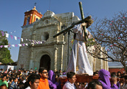
The spread of Christianity was not always peaceful, however. Although millions of people converted to the new religion, others resisted. Conversion was sometimes accomplished by force. Christians and Muslims, in particular, clashed over their religious beliefs. In many cases, Christianity also adapted to local cultures. In Latin America, for example, Christian beliefs blended with native traditions, producing a faith that was more meaningful to the local population.

Over the centuries, Christianity has had a great impact on culture and society. As with Judaism, Christian ethics have influenced codes of law in many countries. Christian charity has helped millions of poor and suffering people. The power of Christian belief and institutions has also influenced politics and government. Throughout history, many rulers have depended on the support of Christian churches to gain and hold power.
Summary:

